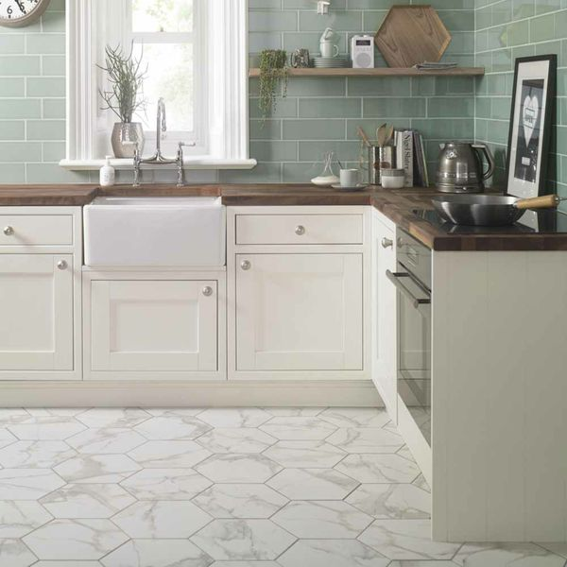**Voronoi White Marble Effect Hexagon Tiles:**

## **Product Description**

Welcome the hexagonal trend into your home this season with these gorgeous Voronoi White Hexagon Tiles. They have a realistic Carrara marble effect design; alive with grey and brown veining draped across a white backdrop. They allow you to create a natural look in a bathroom, kitchen or living room, whilst also introducing some modern, six-sided style. Made from porcelain, they can be used on both walls and floors, and they have a satin sheen and are also suitable for underfloor heating.

**What's special about these tiles?**

> Modern hexagon shape

> Natural marble effect design

> Hardwearing porcelain

> Shimmering gloss finish

**Try before you buy**

Want to take a closer look at these tiles before placing a full order? Order a sample tile! Samples come full size and with Free Delivery, and they're a great way to get a feel for a tile's size, colour and texture. You can even see how it looks on the wall or floor in your chosen space.

## **Product Info**

* Product ID: 15201
* Tiles Per SQM: 14.310684840116
* Sale by: Per SQM
* Size: 330x285x9mm
* Weight: 1.45 KG
* Material Type: Porcelain
* Finish: Satin
* Colour: White
* Suitability: Floors, Walls
* Grade: 4
* Rectified Edge: No
* Underfloor Heating: Yes
* Thickness (mm): 9